 | Total Brand Security Ltd  29 Harley St  London W1G 9QR | Phone: +44 20 7043 6128  Fax: +44 20 3004 1444  E-mail: adrian.simmons@totalbrandsecurity.com

TBS Security Code Desktop Application Manual


Contents
Menus 3
Security Code 4
Products 5
Region 7
Text File 8
Security Code 10
Multiple Security Codes 11
Flow of desktop application is 12

The icon and the text of desktop shortcut

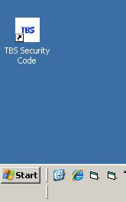

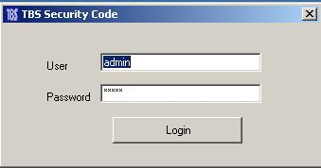
The icon and the text of
Login window

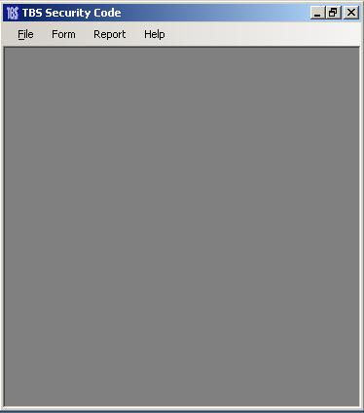
The interface with menus

Menus
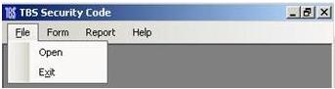

File menu has two sub menus “Open” and “Exit”
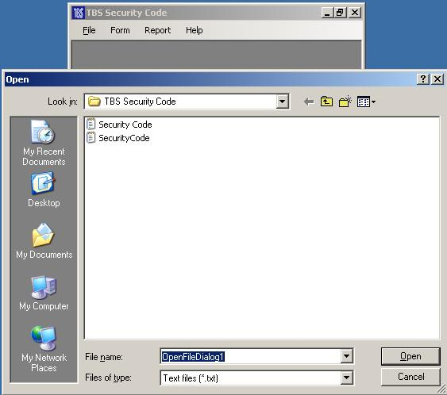
Open
It helps to open text file of Security codes.

Exit
To quit the application

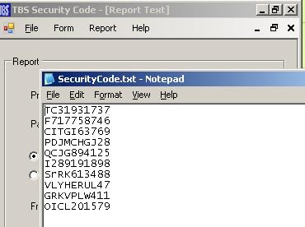

Texts file of Security Codes

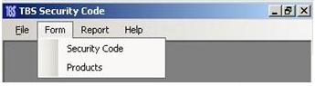

Form menu has two sub menus “Security Code” and “Products”

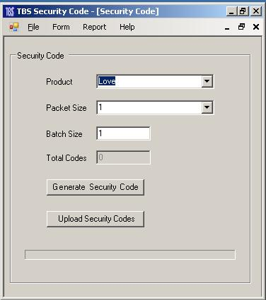
Security Code
It opens the Security Code form where Codes are generated.
There are defining Product, Packet Size, Batch Size, Total Codes and two push buttons.
Product -> It is a product selection combo box from which user can select the desire product for generating security codes.
Packet_Size-> It is a packet size select ion combo box from which user can select the desire one for generating security codes.
Batch_Size-> It is a input text field where user enter the required batch size or number of required serials by default it sets the packet size value but user can edit it.
Total_Codes-> It is an indicator that shows the total number of generated security codes.
Push buttons
Generate_Security_Code-> it uses for generating security codes
Upload_Sec urity_Codes-> it uses for uploading security codes at server.

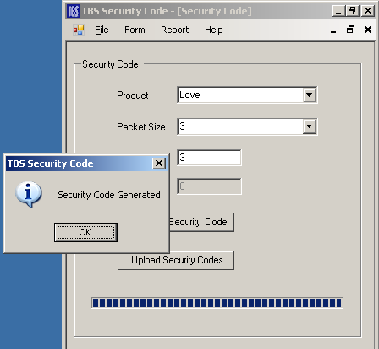

Products
It opens the Products form where user can add the products for the application and these products appears in Security Code form.
User can add, delete and edit the packet size of the products.
There are defining two portions
- Products
- Packets
Products
In this portion user can add products.
There are defining Product combo box and push buttons “Add, Save and Cancel”
Add-> It change the product combo box into input text field where user could enter product.
Save-> by the time product form opens it will be disabled until and unless user pushes the add button for adding product
By using it user can save the product into application.
Note: Currently deleting facility is not available in this version so please make sure the product is being save is correct.
Cancel-> by the time product form opens it will be disabled until and unless user pushes the add button for adding product
It facilitates to cancel adding product operation.

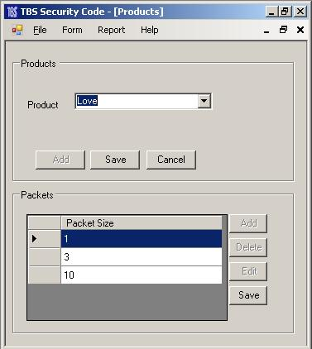

Packets
In this portion user can add packet size of the selected product.
There are defining Packet size grid and push buttons “Add, Delete, Edit and Save”
Packet Size Grid-> It shows the packet sizes and user can add, delete, Edit and save the packet size.
Add-> It adds new row in the packet size grid for inserting size value.
Delete->User can delete the packet size form the packet size grid by using it, just select the row and push delete button.
Edit-> User can edit the packet size form the packet size grid by using it, just select the row and push Edit button, it will enable edit in grid now user can edit packet size by selecting column.
Save-> after finishing packet size editing use it for saving data into application.

Packet Size Grid
Select row from here

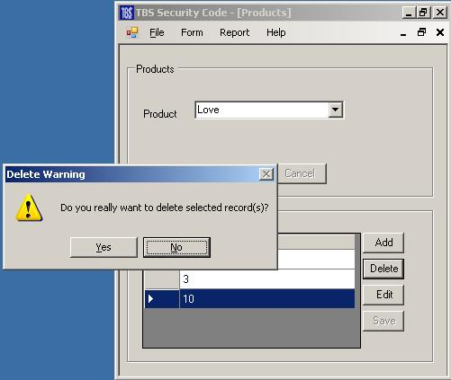

Delete Warning
When the user going to delete packet size the message box appears for confirming that user really want to delete the record.

Region
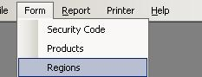
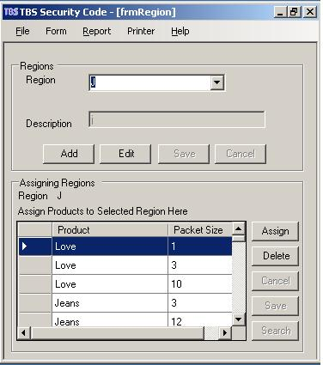
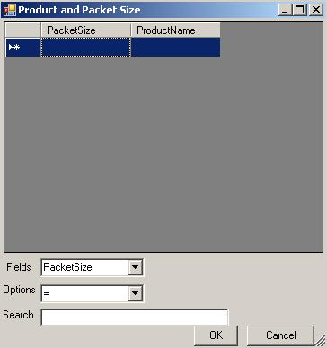
This is newly added window for region; here user can add not only new regions but also edit it’s description.
After adding regions user is able to assign regions to products.
Under Regions group there are four buttons.
Add – It uses to add new region.
Edit – It uses to edit the region description.
Save – It uses to save newly region in to db.
Cancel – It uses to discard newly change.
Under Assign Products group there are five buttons.
Assign – It uses to assign region to products.
Delete – It uses to delete region relation to products.
Cancel – It uses to discard newly change.
Save – It uses to save newly changes.
Search – It uses to search the products for assigning the regions. By using this button there will appear another window Product and Packet Size in this window user will find the product name and packet size for assigning it to selected region that select from previous window.
There is a grid that shows all those products that is not assigned to the region. User can assign only one product at a time by selecting a row.
Searching Options
Fields – It uses to select the product name or packet size for searching by one of them.
Options – “=” for equal, “<” for less than, “>” for Greater than and “<>” for Not equal.
Search – Here user can enter the packet size or product name for searching.
OK – It uses to confirm the assigning and Cancel – It uses for going back to previous window.

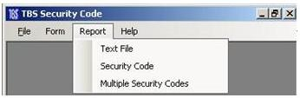

Text File
Report menu has three sub menus “Text File”, “Security Code” and “Multiple Security Codes”
Text File
It will open the form for generating text file interface by using it user could create the text file of security codes.
There are defining Product combo box, Packet size combo box, two radio selection options (Security Codes Not Uploaded or Security Codes Uploaded), Select Date and Generate Text button.
Product-> for selecting Product.
Packet Size-> for selecting Packet size.
Radio Options-> for selecting security codes that Security Codes (Upload or Not Upload).
Select Date-> by using it user can select the date for creating text file. The date option gives facility to get only security codes that have been created specified dates.
Generate Text-> It generates the text file.

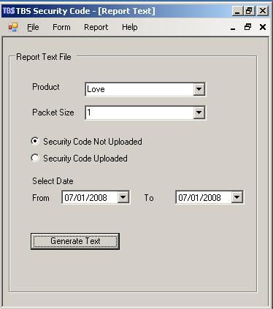

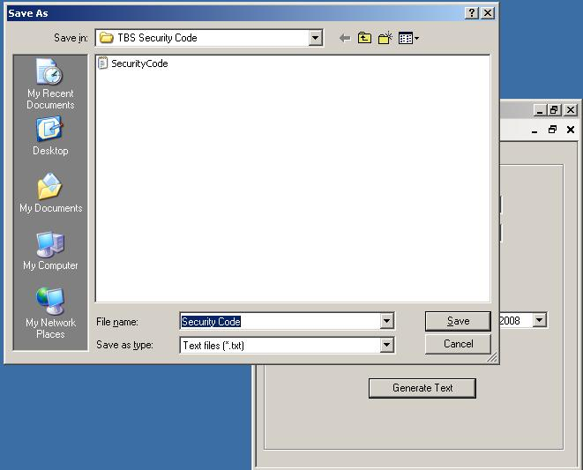
Save File Dialogue
In this dialogue user could save generated file in .txt format.
Note: Default name of the file is Security code but user can change it and also save it his desire location.

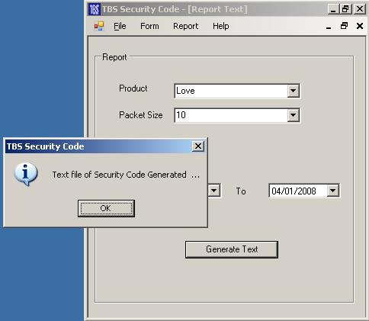

Text File Generated Message
It is security codes text file creating message.

Text File
It is generated text file.

Security Code
Security Code
It will open the form for showing single security code interface by using it user could show the report of security codes.
There are defining Product combo box, Packet size combo box, two radio selection options (Security Codes Not Uploaded or Security Codes Uploaded), Select Date and Show button.
Product-> for selecting Product.
Packet Size-> for selecting Packet size.
Radio Options-> for selecting security codes that Security Codes (Upload or Not Upload).
Select Date-> by using it user can select the date for creating text file. The date option gives facility to get only security codes that have been created specified dates.
Show-> It shows the report.

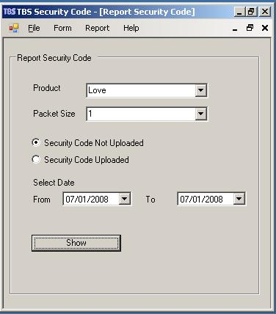

Security Code Report
It is Single Code report with Report Header and header will appear only first page.

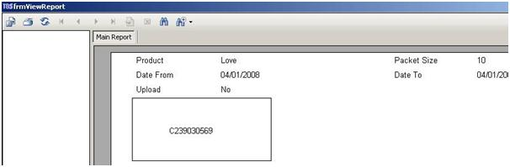

Multiple Security Codes

Multiple Security Codes
It will open the form for showing single security code at one page interface by using it user could show the report of security codes.
There are defining Product combo box, Packet size combo box, two radio selection options (Security Codes Not Uploaded or Security Codes Uploaded), Select Date and Show button.
Product-> for selecting Product.
Packet Size-> for selecting Packet size.
Radio Options-> for selecting security codes that Security Codes (Upload or Not Upload).
Select Date-> by using it user can select the date for creating text file. The date option gives facility to get only security codes that have been created specified dates.
Show-> It shows the report.

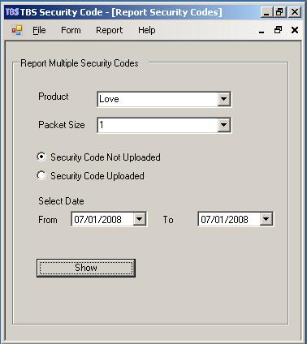

Multiple Security Codes
It is Single Code report with Report Header.
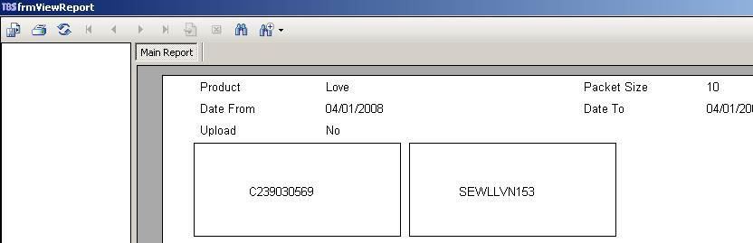

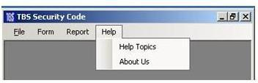
.

Report menu has three sub menus “Help Topics”, “About Us”
Help Topics -> it can be used for user guide in order to use this application.
About us-> it can be used for brief description about TBS Security Code.

Flow of desktop application is
Operator Select the product and packet size and instructs the application to generate the security codes, no matter how many codes he wants to generate whether 1 or 1000, he merely needs to define batch size in security code form.
Know operator can get security codes in text file or in Crystal report. Using report option
As far as “Imaje” printing is concern, operator can use security codes text file in order to take print it.
If operator needs to add more product or packet size, so he can add it as well by using Product Option.

